**Lesson 9 Practice Hands-On**

**Directions**

For your Lesson 9 Practice Hands-On, you will be practicing your new skills. This Hands-On will not be graded, but we encourage you to complete it. The best way to become a great programmer is to practice! Once you have submitted your project, you will be able to access the solution on the next page.

**Setup**

1. Start off by downloading the starter project and unzipping it. The starter project will be in a folder named angular-L9-handson.

[**Starter Project**](https://repo.exeterlms.com/documents/V2/Angular2/V2/angular-L9-handson.zip)

1. After unzipping, move the starter project folder to the FEFAngular folder located inside the FullStackWeb folder and rename it from angular-L9-handson to L09HandsOn.
2. Open up your terminal/command prompt.
3. Run the following to navigate to your Desktop
4. cd Desktop
5. Next, navigate to the FullStackWeb directory in your terminal.
6. cd FullStackWeb
7. Then, navigate to the FEFAngular directory in your terminal.
8. cd FEFAngular
9. Navigate into the L09HandsOn directory:
10. cd L09HandsOn
11. Now that you are in the L09HandsOn directory, run the following:
12. npm install
13. Next, run the following:
14. npm install typescript@2.8 --save-dev

**Requirements**

For this Hands-On, you will add a **View** button below the movie poster. When clicked, it will pass the image URL of the movie to the parent component, such that it can open it in a new window.

**Step 1**

* Add a button named View to the display-movie HTML below the movie poster.
  + When clicked, it should target a method similar to the method for the Delete button.
  + This method must pass in the movie's image url.
* Add a new @Output property that uses the EventEmitter to the DisplayMovieComponent class.

Hint! The EventEmitter will *not* be of type number. It will be the same type as the image's url in the model, since you will be passing the image url into the parent component.

* Add the method from your View button into the display-movie ts file.
  + This method will need to use the necessary property and method.
* Within the display-movies ts file, add a method that will handle opening a new window with the image url. Below, you can find code that will allow for a new window to open with the image url:
* window.open(url);
* Add the necessary code within the <app-display-movie> tag that will target the method within the display-movies component.
* Make sure both servers are running. When the View button is clicked, it should take you to a new page where the movie's poster will be displayed.

**Example**

When finished, your project should look similar to the following:

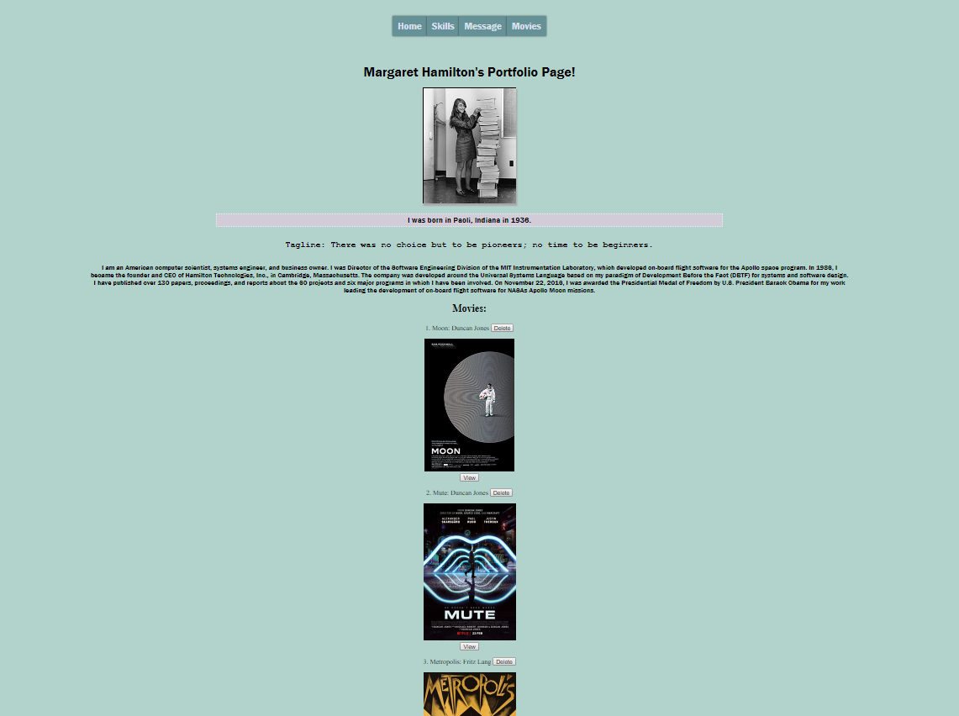

Movie poster displayed:

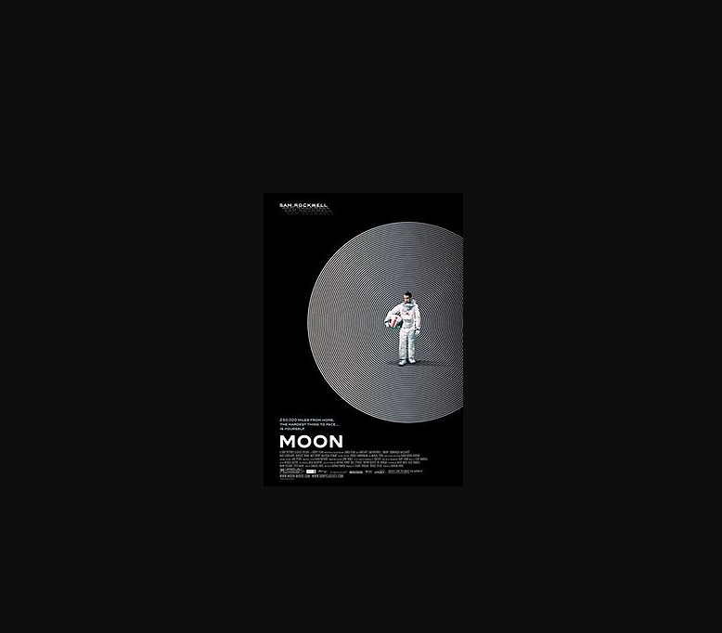

**Caution!**